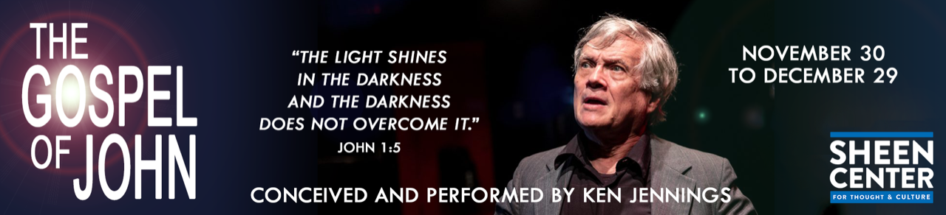

This December, The Sheen Center brings to [The Gospel of John](https://urldefense.proofpoint.com/v2/url?u=http-3A__r20.rs6.net_tn.jsp-3Ff-3D001LRV-5FOgfnQUk6iAyPR55DP6ts9b5QC41wXlVA3nhk-5FSss3MwyT1Lkn0mct0u5jsplv4R31QyeznJC-2DaWdDSCezFk9hbv6ClicMR-5FZxhyoJRIEWtdiae2wuVhLxMCcCwoKbsxHIszt8mCyHrFotSKKyVC37B9X-5FzBu8d0n6S6nZrxVPuwjB8-5FMI16OTgpcZ0QztiDBF0ow4ZrXQilpaUHk5g-3D-3D-26c-3DFwQCQUHEHVSRxSgTYrD7fWIIRGFrXec1-2DjcXP18O3T-2DBivvSSd34Cg-3D-3D-26ch-3DPlJbqEc5XG90EL-5Fb7r7Pa9qiROP-5F6WsYx-5FenTAhpuMvTVfP48UyYPQ-3D-3D&d=DwMFaQ&c=xRhiN2BRwJUM6w5u-Ngs3w&r=gfzVdY3hm9d5poMdipJd5VitVpyJKZUYG0RV6Cbi8rg&m=phSSghkGvAzCtH_ObUjE_7Dmk60TnmIdgANDGx9L4Pk&s=m1p0A7QJknE3B3p6xzmJAA_3PFwLlsj6mj8vqG3lYhg&e=) to the Black Box Theater Stage. Be inspired by the light and hope of this unique theatrical experience that invites audiences of all walks of life to experience the Mystery of the Incarnation in an unexpected context. True to the text and reverently performed in an abbreviated format by acclaimed Broadway actor Ken Jennings, this play brings the Gospel to life through the deeply personal gaze of the Beloved Disciple.

For 26 performances, beginning November 30 and concluding on December 29, Ken will proclaim the Gospel as many first-century audiences may have originally experienced it - as a virtuosic and heartfelt retelling of the greatest story ever told.

This unique performance of the St. John’s Gospel is a breathtaking account of the life of Jesus, which is as beautiful in verse as it is profound in wisdom. We invite you and your parishes to please come and witness this personal encounter with the Living Word as expressed in this 90-minute theatrical piece.

Tickets are available at [sheencenter.org/shows/john/2019-11-30/](https://www.sheencenter.org/shows/john/2019-11-30/)

Use Promo Code: ARCH for a 20% discount on tickets