Bishop Ronald A. Hicks
Bishop Ronald Aldon Hicks was born on August 4, 1967, in Harvey, Illinois, to Ronald and Roselee Hicks. He has a younger brother, Rick. He grew up in South Holland, Illinois, where he attended St. Jude the Apostle Parish and grade school.
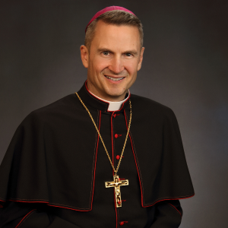
He graduated from Quigley Preparatory Seminary South in 1985. He received his Bachelor of Arts degree in philosophy from Niles College of Loyola University, Chicago, in 1989, and both his Master of Divinity degree in 1994 and his Doctor of Ministry degree in 2003 from the University of St. Mary of the Lake in Mundelein, Illinois.
Bishop Hicks was ordained to the priesthood for the Archdiocese of Chicago on May 21, 1994. He served as an associate pastor at Our Lady of Mercy Parish in Chicago from 1994 to 1996 and at St. Elizabeth Seton Parish in Orland Hills, Illinois, from 1996 to 1999. From 1999 to 2005, he lived and ministered at St. Joseph College Seminary in Chicago as the dean of formation.
In July 2005, with permission from Cardinal Francis George, Bishop Hicks moved from Chicago to El Salvador to begin his five-year term as regional director of Nuestros Pequeños Hermanos (NPH) in Central America. NPH is a home dedicated to caring for more than 3,400 orphaned and abandoned children in nine Latin American and Caribbean countries.
From 2010 to 2014, Bishop Hicks served as the dean of formation at Mundelein Seminary. During that time, he assisted with weekend Masses at St. Jerome Parish in the Rogers Park neighborhood of Chicago.
Bishop Hicks was appointed vicar general of the Archdiocese of Chicago by Cardinal Blase Cupich on January 1, 2015. On September 17, 2018, he was ordained an auxiliary bishop of the archdiocese at Holy Name Cathedral in Chicago.
On July 17, 2020, Pope Francis announced that he had named Bishop Hicks as the sixth bishop of the Catholic Diocese of Joliet, Illinois. He was installed at the Cathedral of St. Raymond Nonnatus in Joliet on September 29, 2020.
Bishop Hicks serves on the Committee on Clergy, Consecrated Life and Vocations for the U.S. Conference of Catholic Bishops (USCCB), and as the USCCB liaison to the Association of Ongoing Formation of Priests and the National Association of Diaconate Directors. He has also been appointed to the USCCB’s Charter Review Workgroup. He also serves on the board of the Catholic Extension Society and the Mundelein Seminary Advisory Board.

