**Man Up New York**

I would like to share with you some information about our upcoming men's conference, Man Up New York, *Manning up in the face of adversity. St. Joseph-Model of True Manhood.*It will be a day of fellowship, spiritual enrichment, and practical insights on how to live out our faith during this time of adversity. We will be joined by His Eminence Timothy Cardinal Dolan, Fr. Don Calloway, Mike Piazza, and Dr. Greg Bottaro!

* **When**: Saturday, October 23rd, 2021
* **Where**: St. Joseph’s Seminary, Yonkers

Join us with your men's group. We also have follow-up resources for your men's group.

We would greatly appreciate your assistance with hearing confessions from 12pm-1:30 pm. There is no cost for clergy, **but registration is required.**

To sign yourself up, go to [manupny.com.](https://www.manupny.com/)

**Free Parish Watch parties**

**If you would like to hold a watch party at your parish, there would be no cost for your parishioners to participate in the conference.** Contact us for more information at [adultfaithformation@archny.org](mailto:adultfaithformation@archny.org) or at 646-794-2581.

[**Save your spot today!**](https://www.manupny.com/)

[Download Man Up New York flyer PDF](https://archny.org/wp-content/uploads/Man-Up-poster.pdf)

[Download Man Up New York web graphic JPG](https://archny.org/wp-content/uploads/Man-Up-web-graphics_Facebook-Twitter-ad.jpg)

[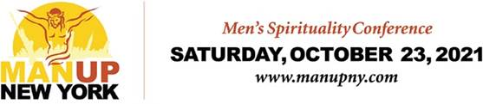](www.manupny.com)