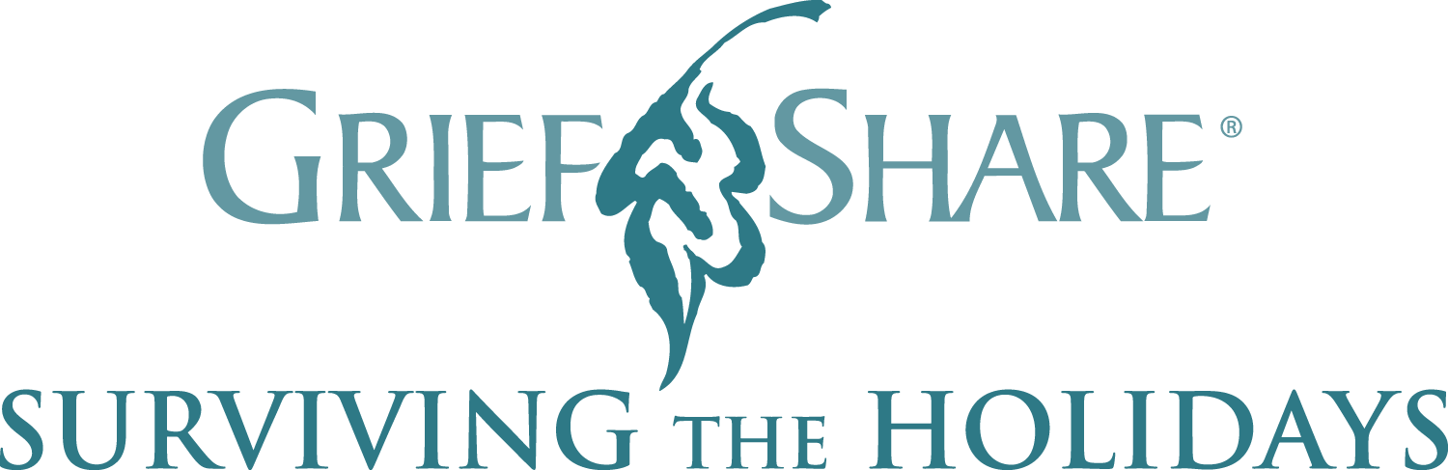

The bereavement ministry of the Family Life office will present GriefShare: Surviving the Holidays. This program is a helpful, encouraging seminar for people facing the holidays after a loved one’s death. Please join us on Wednesday, November 13, 2019 from 6:00pm -8:30pm at The Catholic Center (1011 First Avenue, NYC)

The seminar features video interviews with counselors, grief experts, and other people who have experienced the holidays after their loved one’s death and who offer practical suggestions and reassurance. These people share honestly about:

• Being prepared for surprising emotions that may hit over the holidays
• What to do about traditions and other coming changes
• How to handle holiday parties and invitations
• How to survive potentially awkward moments with other people
• Where to find comfort, strength, and hope in a seemingly hopeless time

Those who attend will receive a Survival Guide filled with practical tips, encouraging words, journaling ideas, and exercises for daily help through the holiday season.

For more information or to RSVP by Friday, November 8th, call Vinny DaSilva at 646-794-3168 or Vincent.dasilva@archny.org

