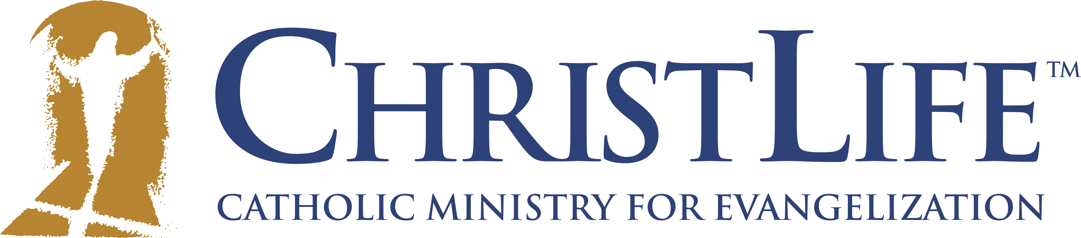
Seven weeks can change your life!

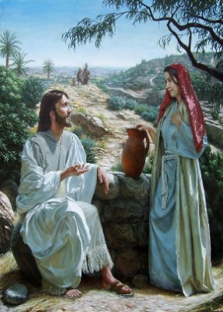
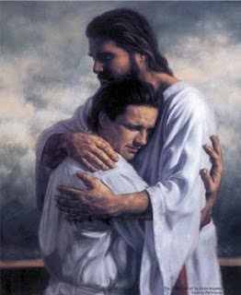
Series One: “Discovering Christ”

St. Ann’s Catholic Parish (Yonkers)
Thursdays from March 5 – April 23, 2020
(Except April 9th, 2020)
6:45 PM – 9:00 PM, Fr. Anthony Hall
Retreat: Saturday April 4th, 9 AM-4 PM

Join us for dinner, discussion, and prayer to discover the difference a life lived in Christ can make for you!

ALWAYS REMEMBER…TO BE BOLD IN CHRIST!

I’d like to hear more about ChristLife and/or sign up!

Name _____________________________________________________________

Address: __________________________________________________________

Email: ____________________________________________________________

Phone: ____________________________________________________________

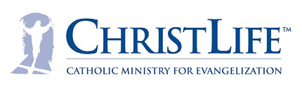
Gender: M______ F_______

Approx Age: ____________

Questions? Call 914-965-1555 or email stannsyonkerschristlife@gmail.com
Please return application to St. Ann’s Rectory.

