Dear Pastors,

We are thrilled to announce a $1,000,000 matching challenge for the Cardinal’s Annual Stewardship Appeal from an incredibly generous donor. Please use this incentive to encourage your parishioners to give before December 31, 2021 if they haven’t already.

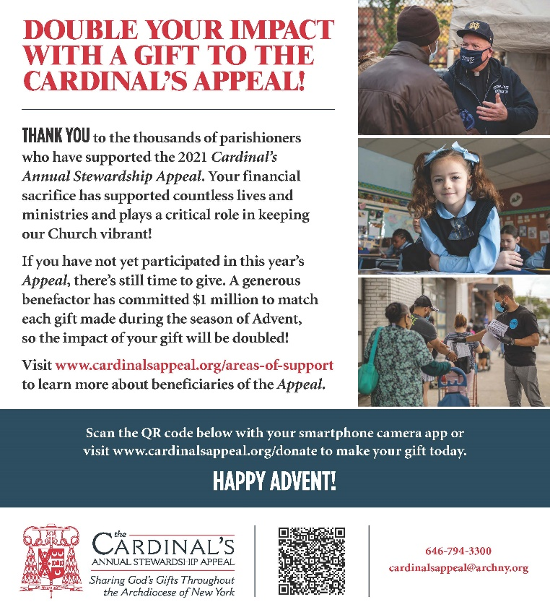

Thank you for your dedicated efforts throughout the year to ensure the 2021 Cardinal’s Appeal is successful. Despite the many challenges we have all faced, it has been a fruitful year. I would especially like to thank Juliette Picciano, the Director of the Cardinal’s Annual Stewardship Appeal, for her leadership and our incredible team of Campaign Managers. The Development team values your partnership immensely. Thank you for bringing our Catholic faith to the people of the ADNY.

Be assured of my prayers for you this Advent and Christmas season. Wishing you the very best in the New Year!

Best,

Bettina

Bettina Alonso
Executive Director of Development
Development Office

1011 First Avenue, 14th floor ǀ New York, NY 10022
www.archny.org |www.cardinalsappeal.org
Office: 646.794.3393 ǀ Cell: 646.251.0045
Email: bettina.alonso@archny.org

