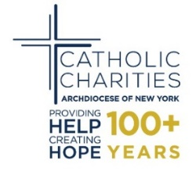

Pastors,
This April we will be asked to complete the United States Decennial Census. It is critical that every person is counted.

I am asking that you join me in encouraging participation in the 2020 Census.

Census data is important to ensuring that all communities are properly represented and cared for. The information collected through the Census helps to determine political representation and critical funding for many programs such as education, infrastructure, Medicaid, SNAP, Section 8 Housing, and other government aid.

Notices and forms from the United States Census Bureau will start arriving in the mail in March 2020. Follow-up with households that do not complete the forms during the initial period will begin in April 2020 and conclude in July 2020.
The 2020 Census will be the first high-tech Census, with the addition of an online response option. Respondents will have three (3) other ways to complete the census: by phone, by mail and with a census taker.
We are asking parish leaders and staff to use their position to help educate and mobilize our community to rise to this challenge.
Enclosed you will find materials to help you and your parish. Please adapt them for your use. Included are:
- Sample Bulletin Announcement
- Frequently Asked Questions
- Checklist and Timeline
- Flyer to display in the church

Catholic Charities is available to provide additional information and support to you to ensure a successful count. To discuss your participation, please contact Luz Tavarez at 646-794-3784.
Thank you once again for all that you do.
Sincerely,
Monsignor Kevin Sullivan
Executive Director

NB - There has been an important discussion of confidentiality regarding census data. There is no question about citizenship on the census form and the confidentiality of all data collected is protected by the Constitution.

