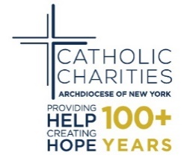

CENSUS 2020: A CATHOLIC CHARITIES RESPONSE
Checklist and Timeline

How You Can Help:
- Remind parishioners to count all the people living in their home
- Remind parishioners that School districts use census data about families and children to make long-term building, staffing, and funding decisions.
- Assure all parishioners that all information collected will remain confidential
- Remind parish staff of the upcoming enumeration

January - February 2020: Awareness Phase
- Census Pulpit Announcements
- Homilies emphasizing the importance of the being counted
- Bulletin Announcements
- Parish Emails and News Stories
- Fliers/Posters
- Social Media/Newspapers/Radio
March - April 2020: Motivation Phase
- Organize a day(s) to help parishioners to complete their forms
- Hold events at the parish to answer questions & provide information
- Texting/Messaging Reminders
- Encourage parishioners to talk with people in the community about the importance of the census
May - June 2020: Reminder Phase
- Remind Parishioners to work with enumerators and complete their Census forms

