What has become of CCD?
Has it disappeared?
When our Holy Father, Pope John Paul II, spoke at St. Patrick's Cathedral in October, 1995, he said: "/ know that the Archdiocese of New York is proud of… its Religious Education programs."
"Religious Education": what is that supposed to mean? Why don't our Holy Father and the Church talk about CCD anymore? Here is the answer.
How CCD became your Parish Religious Education Program
For many years, CCD (the Confraternity of Christian Doctrine) provided Catechism lessons to children and youth not attending Catholic School. It was a wonderful program for its time.
However, the Second Vatican Council called for some new thinking about the way Catholics are to be formed in their faith.

The Church developed a new approach to teaching the Faith
In Vatican II, the Church reaffirmed that Catholics of all ages are entitled to an ongoing and deeper understanding of their faith. As a result, it is the commitment of every diocese in the country to offer religious education of the highest quality to all Catholics. Every parish, therefore, gives a high priority to formation in the faith for every parishioner - child, youth or adult. Every Catholic family is called to seek out religious education for each of its members.
A new name for a new approach
In each parish, too, we have grown from a small program only for children and youth (CCD) to providing faith-formation for people of all ages. This more comprehensive approach is called Parish Religious Education/Catechesis. Catechesis is an ancient and revered word in the Catholic Tradition. It includes both education in the faith and life-long formation in following Jesus.

Catechesis in the wider Church
Our Holy Father has said: "As the 20th century draws to a close, the Church is called by God and by events to renew her trust in Catechetical activity as a primary aspect of her mission. She is bidden to offer catechesis her best resources in people and energy without sparing effort, tailor material means...”
Something for everyone
Each parish is part of the Catechetical endeavor of the entire New York Archdiocese. In approximately 413 parishes, there are over 7,800 catechists teaching more than 110, 000 children and adults. Our parish program offers something for everyone:
- Families
- Pre-schoolers
- Elementary school children
- Adolescents, Grades 7 through 12
- Young adults
- Adults
- Senior citizens
- People of all ages with special needs
Would you like to know more about the Religious Education programs offered here in this parish? Would you like to help us? Just call for information.
We'll be happy to talk with you and tell you about our programs, how you can enroll a child or how you can assist us in this very important ministry.
What if you're not a member of the parish?
Call anyway. We'd like to meet you.

++++++++++++++++++++++++

Name of Director/Coordinator of Religious Education
Parish Name
Parish Address
Phone
Best time to call

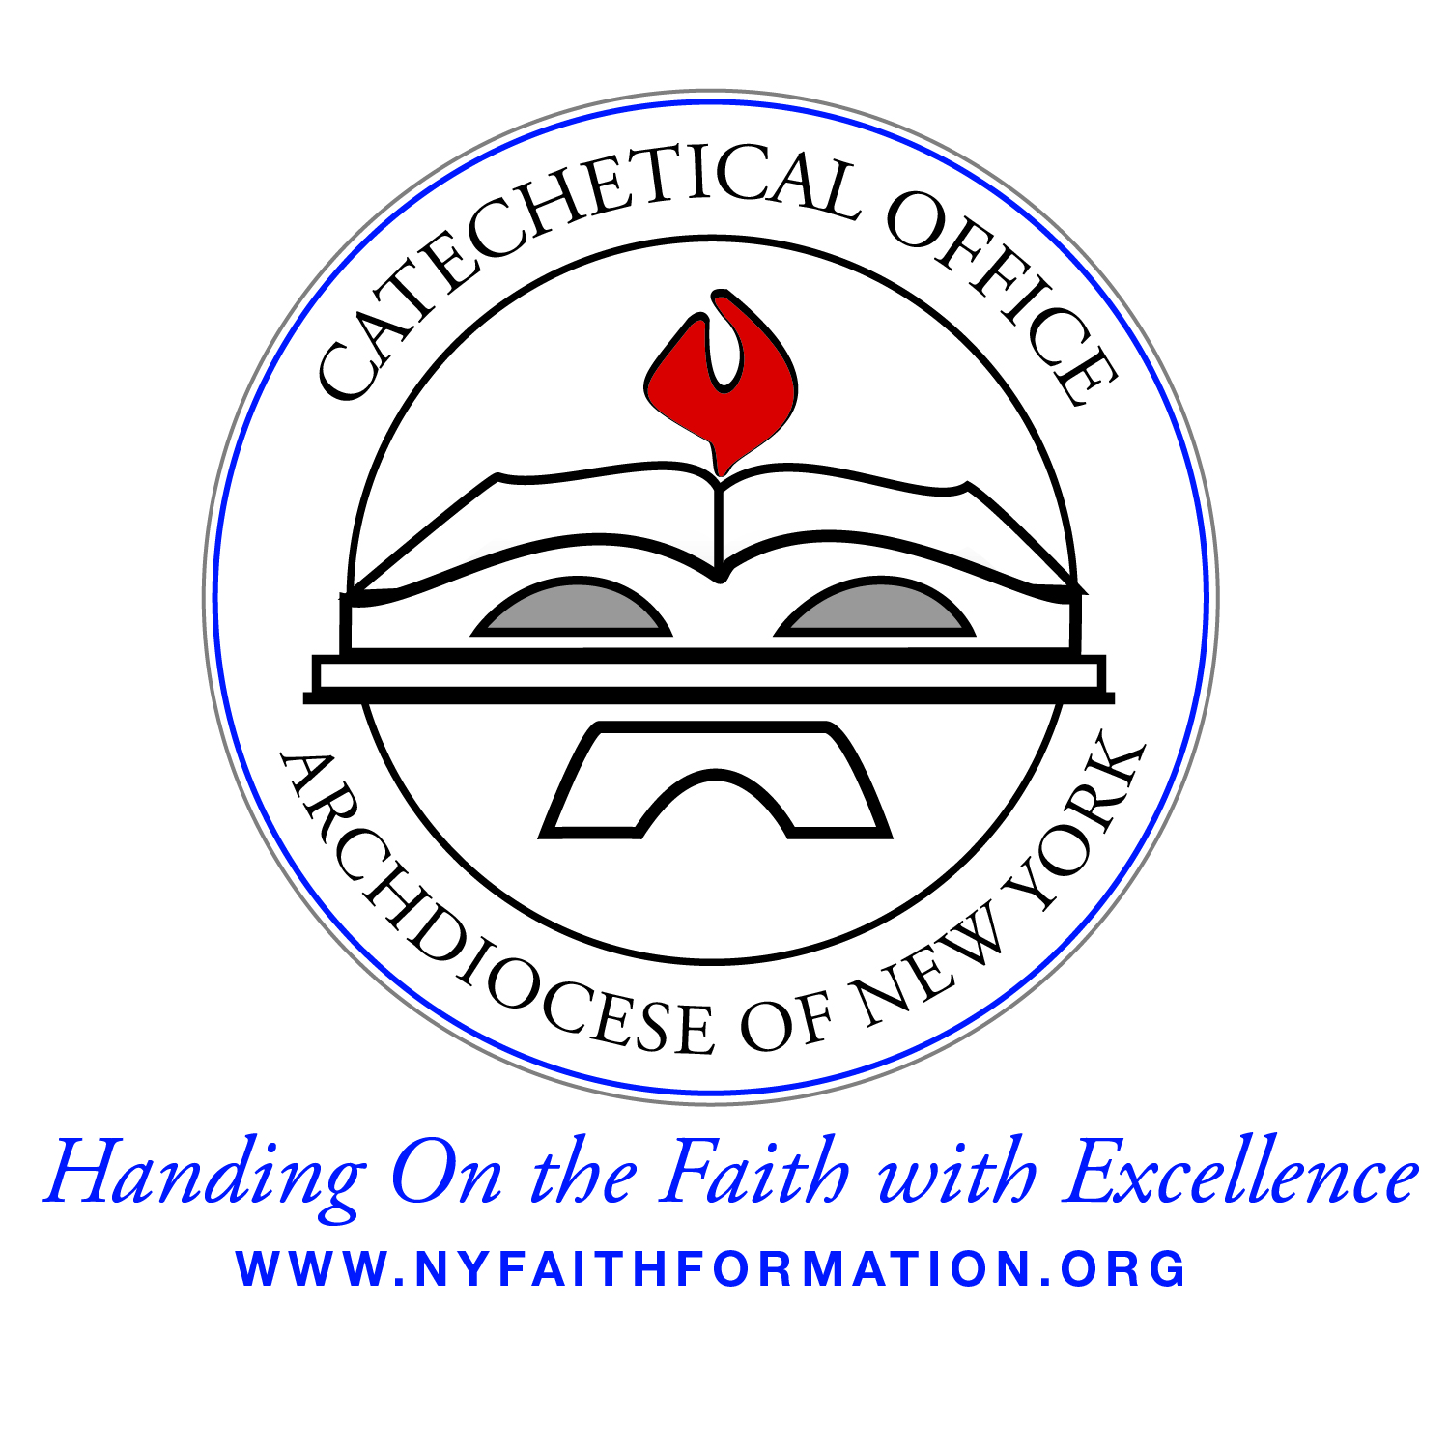

A Publication of the Archdiocesan Catechetical Office
1011 First Avenue
New York, NY 10022 Copyright: 1996

Whatever Happened to CCD?
Catechetical Office Archdiocese of New York

