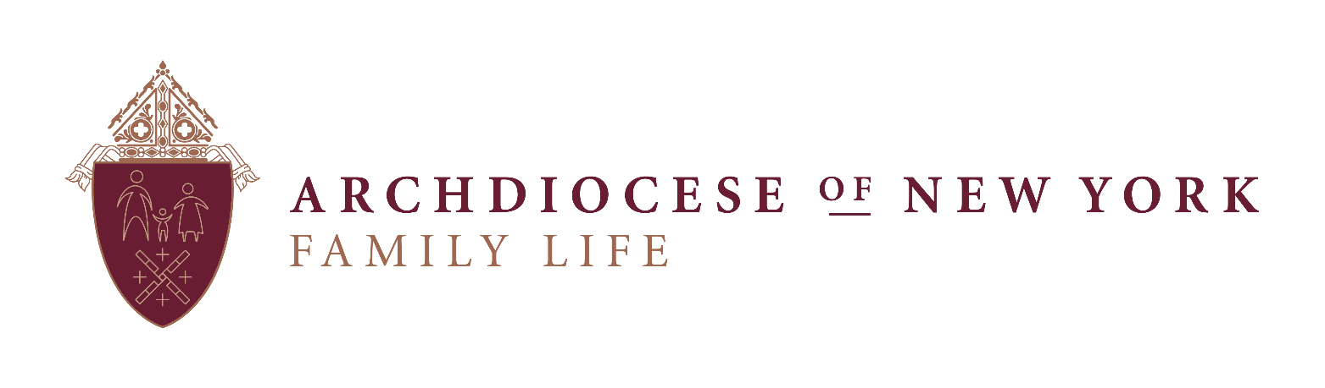

June 2019

Dear Pastor/Administrator and Parish Staff,

I am pleased to share some opportunities for you to support and celebrate **National NFP Awareness Week** (July 21 - July 27, 2019). To focus attention on Natural Family Planning, and to promote God’s plan for married love during this week, below are some resources that you may find helpful to use or reference:

**From the USCCB:**

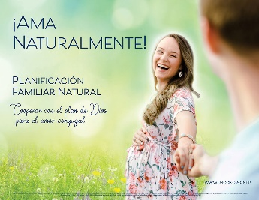**“Love, Naturally!”** is the theme of this year’s Natural Family Planning Awareness Week, and to purchase posters or download saleable images, visit: <http://www.usccb.org/issues-and-action/marriage-and-family/natural-family-planning/awareness-week/posters.cfm>

For other resources such as **Homily Notes, Prayers of the Faithful**, and **media resources**, visit the NFP Week Homepage at: <http://www.usccb.org/issues-and-action/marriage-and-family/natural-family-planning/awareness-week/index.cfm>

**From the Family Life Office:**

The Family Life Office is offering **free** online and in-person [90 minute] FEMM Intro Sessions or Creighton Intro sessions (English and limited Spanish) **during the month of July** (Class sessions are limited, and are available on a first-come-first-serve basis.)

For more information, or to take advantage of this offering, email Kathleen Crayne in the Family Life Office at [Kathleen.Crayne@archny.org](mailto:Kathleen.Crayne@archny.org).

Thank you for helping us spread the word about God’s design for married love and the gift of life! If you have any questions, please don’t hesitate to contact me directly at [dr.kathleen.wither@archny.org](mailto:dr.kathleen.wither@archny.org)or 646.794.3186.

United with you in prayer,



Kathleen Wither, D. Min.

Director, Family Life Office