Eucharistic Revival Update

This Corpus Christi kicks us the year of the Parish Revival (2023-2024)! The USCCB Revival Team will offer a foundational small group study titled “Jesus and the Eucharist.” This free resource will be ready-made for easy parish use, and its content will begin with kerygmatic proclamation and build to God’s love in the Eucharist. The Revival Team will provide training and support for the parish leaders throughout the process, beginning this spring. This team has also created "The Leaders Playbook" for pastors and lay parish leaders. Resources can be found at this website:

Ministry Resources: Ideas for Local Responses to the Revival (eucharisticrevival.org)
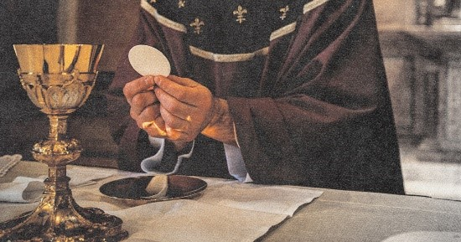 | Ministry Resources: Ideas for Local Responses to the Revival  Find flyers, posters, and promotional ideas to get your ministry excited about the Revival!  www.eucharisticrevival.org

National Eucharistic Pilgrimage

Plans for the National Eucharistic Pilgrimage are being finalized including our Northeast section. The general structure for the pilgrimage will include Mass each morning, often followed by major Eucharistic processions. On weekends the pilgrimage teams will stop in cities for service opportunities; on weekdays there will be minor processions with evening events in parishes. Bishop Colacicco is working with a committee to confirm route and details. As details are confirmed they will be shared on our website: Eucharistic Revival in the Archdiocese of New York - Archdiocese of New York (archny.org)

Eucharistic Revival in the Archdiocese of New York - Archdiocese of New York
Upcoming Events in the Archdiocese of New York Hispanic Cultural […]
archny.org

New York State Conference

All parishes are encouraged to come to the New York Eucharistic Congress to worship with Catholics from the 9 various dioceses in our state. Highlights include Saturday Mass celebrated by His Eminence Timothy Cardinal Dolan and keynotes by Bishop Joseph Espaillat II, Sr. Mary Grace Langrell of the Sisters of Life, and Mother Clare Matthiass of the Franciscan Sisters of the Renewal and much more. Entrance is Free! Register soon as space is limited. Attached is a flyer in English and Spanish to promote in the parish.

National Eucharistic Congress

The 10th National Eucharistic Congress will be held on July 17 – 21, 2024 in Indianapolis.
The Archdiocese of New York has subsidized tickets for our parishes to use. Parishes may purchase up to (5) five tickets at $50 each. They are available to parishes on a first come first served basis. Registration will be on our website for priests: Information for Priests - Archdiocese of New York (archny.org). It is password protected. The password is revival. After filling out the form, you will receive a confirmation email and invoice. Once payment is processed, you will receive a link and code to enter on the registration website of the National Eucharistic Congress. If a parish would like to purchase additional tickets, please check the appropriate box on the form. The parish will be contacted if tickets are available.

Information for Priests - Archdiocese of New York
Appointment of a Parish Point Person We are inviting each […]
archny.org

