NATIONAL EUCHARISTIC REVIVAL
YEAR OF PARISH REVIVIAL (2023-2024)

Draft email text for PARISH PASTOR to ask a STAFF MEMBER
to be the “PARISH POINT PERSON”

Please edit text highlighted in gray, as well as any other text you wish to alter.
Then copy and paste this letter into an email.

NB: Delete this instruction and all of the text above it before this document is sent.

***

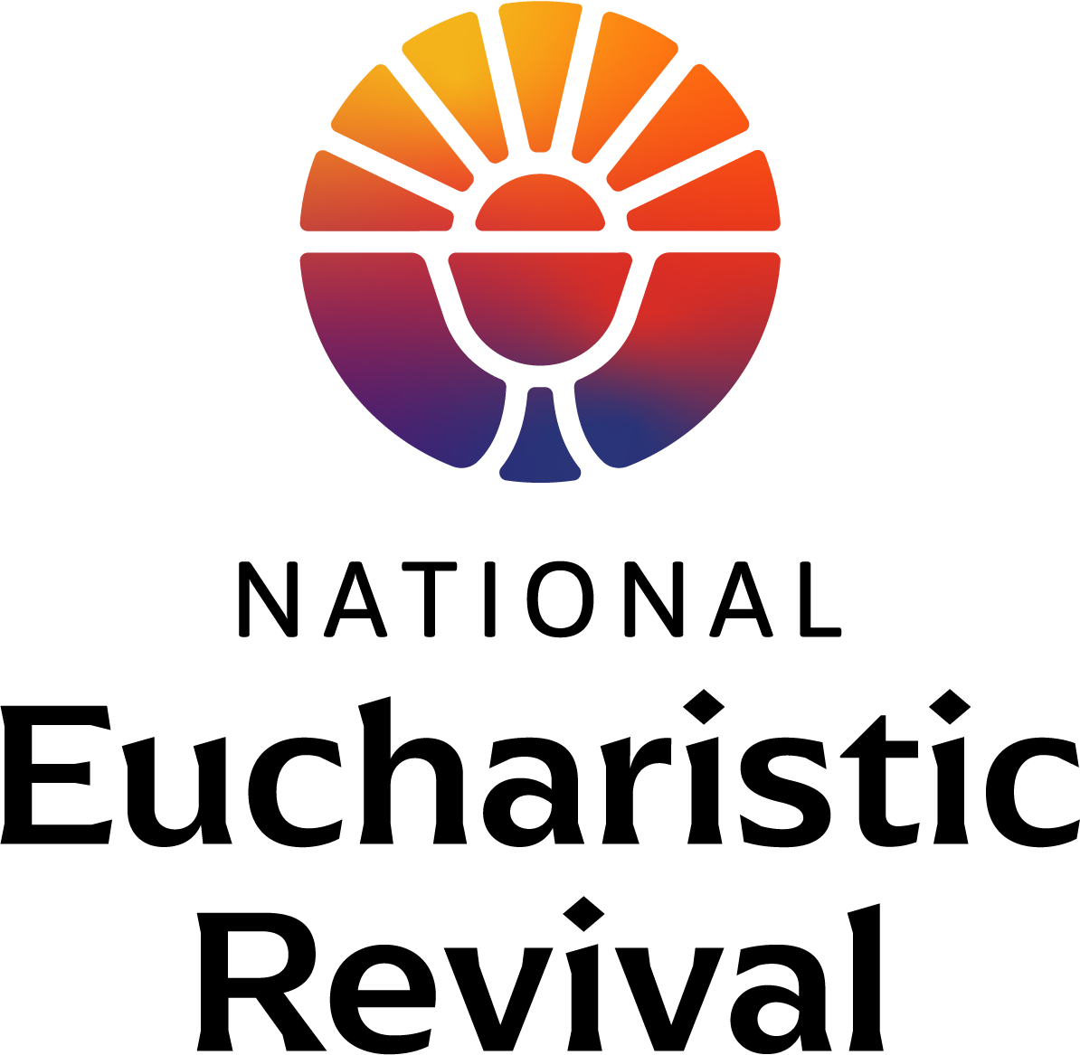

Feb. 8, 2023

Dear [Name of parish staff person; recommend staff responsible for evangelization, faith formation or RCIA]:

The National Eucharistic Revival, a three-year initiative sponsored by the Bishops of the United States, is preparing for Year Two – the Year of Parish Revival (2023-2024). In the Year of Parish Revival, all parishes are invited and encouraged to do two things:

- Eucharistic Revival small groups: Host Eucharistic Revival small groups to help parishioners encounter and grow in their love for Jesus, especially in the Eucharist, while building community in the parish, and

- Parish Playbook: Discern and implement the Eucharistic Revival “Parish Playbook” which offers recommendations for parish activities in each of the four pillars of the Revival: personal encounter with Jesus, reinvigorating devotion, deepening formation, and missionary sending.

You can find more information about the Revival at the website: www.eucharisticrevival.org, and sign up for the weekly newsletter titled “Heart of the Revival”. The website contains an overview of the three-year Revival process along with FAQs.

“Parish Point Person”
The Revival Team is asking each Pastor to assign one staff member to be the “Parish Point Person” for the Eucharistic Revival work at the parish. The role of the “Parish Point Person” in the Year of Parish Revival will be to (1) oversee and implement the Eucharistic Revival small groups and (2) assess and implement the “Parish Playbook” at the parish (to be published in the Spring).

The Role Description for the Eucharistic small group work is provided below. The foundational Parish Year small group study titled Jesus and the Eucharist is 7 sessions long and ready-made for easy parish use. The Revival Team will provide the small group video and materials, along with training and support for parishes, free of charge.

As the [insert title], you are the leader in the best position to undertake this work and I ask you to please lead this effort in the upcoming year. I understand this will be additional work, so let’s meet to discuss how it will fit into your overall workload. You can form a core team to assist you with this work if you wish.

Eucharistic Revival small groups at our Parish and Next Steps
After we have had an opportunity to meet, I will ask you to take the following steps at your earliest convenience:

- Register as our Parish Point Person: Go to this link to submit your name and contact information, along with our parish name and contact information. The Revival Team will then begin to communicate directly with you by email.

- Reserve our Adult Faith Formation Calendar for Eucharistic Revival small groups: I would like to offer the Eucharistic Revival small groups at our parish this upcoming year. The materials are available starting September 17, 2023. When we meet, let’s discuss whether to offer the Eucharistic Revival small groups this fall or winter so you can reserve the calendar.

- Register and attend a training for “Eucharistic Revival Small Group Planning”: Register at www.EucharisticRevival.org on the Parish Point Person section of the webpage, which will be live March 1, 2023.

  - For Fall 2023 small groups, trainings will be offered March 16 through the end of May.
  - For Winter 2024 small groups, trainings will be offered again this Fall (although you are welcome to join one of the trainings starting this March to get a preview).

Thank you, in advance, for all you do for our parish and for your work in this important national movement to help the faithful fall in love with Jesus, especially in the Eucharist, and be inspired and equipped to share that love with others.

In Christ,
[Pastor name]

PARISH POINT PERSON ROLE DESCRIPTION FOR
EUCHARISTIC REVIVAL SMALL GROUPS

- PLANNING FOR EUCHARISTIC REVIVAL SMALL GROUPS

  - Attend a training for “Eucharistic Revival Small Group Planning”
    - Register and attend one virtual training hosted by the Revival Team to plan the Eucharistic Revival small groups at your parish. The trainings will be offered in both English and Spanish.
    - Register at www.EucharisticRevival.org on the Parish Point Person section of the webpage, which will be live March 1, 2023.
      - For Fall 2023 small groups, trainings will be offered March 16 through the end of May.
      - For Winter 2024 small groups, trainings will be offered again in the Fall.

  - Training will include the following topics:

    - Form a Core Team: Form a Parish Core Team to assist you with this work (optional).

    - Plan your Small Groups: Parishes are invited to (i) host “Eucharistic Revival Small Groups” where the parish sets the day and time for the meetings, and then invites all parishioners to participate by simply showing up making it easy to attend, and (ii) encourage existing small groups to make use of these Revival small group materials.

Below is a preview of the small group materials:
      - There will be seven sessions of two hours or less in duration, with no prework or homework.
      - The Revival Team will prepare the videos for the seven sessions. Each week, the parish will download the video in advance and show it to participants.
      - The Revival Team will prepare the member handouts. The parish will download, print and place the member handouts at the discussion tables for each session.

    - Reserve your Parish Calendar and Space: Reserve space at your parish that allows for participants to view the video and engage in their table discussion.

    - Prepare your parish Communications Plan and Calendar

    - Recruit Table Facilitators: Recruit table facilitators, and request they attend one virtual Table Facilitator Training (offered in late August and September for Fall small groups).

- IMPLEMENTATION OF EUCHARISTIC REVIVAL SMALL GROUPS

  - Attend a training for “Eucharistic Revival Small Group Implementation”: Register and attend one virtual training hosted by the Revival Team to prepare for your parish implementation.
    - For Fall 2023 small groups, trainings will be offered in late August and September 2023.
    - For Winter 2024 small groups, trainings will be offered again late Fall.

  - Attend a “Table Facilitator Training”: Register and attend one of virtual Table Facilitator training (same schedule as the Implementation trainings above).

  - Plan the Announcement Weekends: Plan the small group announcement weekends (in early September for Fall small groups). Sample homily messaging, pulpit announcements, and parish electronic communications along with a bulletin stuffer will be provided.

  - Implement the Eucharistic Revival small groups at your Parish

